**Job Portal Application**

**1. Scope**

The primary objective of Job Portal application is to serve as a platform connecting job seekers with employers, facilitating the process of job discovery, application, and recruitment.

The application will cater to two main user roles:

* **Job Seeker**: Individuals looking for employment opportunities.
* **Employer**: Organizations or individuals looking to hire new talent.

**2. Requirements**

1. **Job Seeker Module:**

* Registration/Login/Logout via email & password.
* Profile Management: Add/update name, contact, education, experience, skills.
* Resume Entry (text-only) pdf/doc will be added to working with database.
* Profile Completeness: Show profile completeness percentage.
* Job Search:
  + Browse all jobs
  + Filter by keyword, location, job type, category
  + View full job details
* Job Application:
  + Apply using profile info
  + Track application status (Applied, Reviewed, Interview, Rejected, Waiting List, hold).

1. **Employer Module:**

* Registration/Login/Logout with company name, email & password.
* Company Profile: Add/update name, description, industry, website.
* Job Posting:
  + Add/edit/delete jobs with full details
  + Fields: title, description, requirements, location, salary, type, category
* Applicant Management:
  + View applicants per job
  + Update status (Reviewed, Shortlisted, Rejected, Waiting List, hold)

3. Detailed Page-wise Workflow

1. Homepage:
   * Displays a brief introduction to the portal.
   * Navigation links for "Job Seeker Login/Register" and "Employer Login/Register".
   * A search bar for quick job search (without login) for applying the jobs Registration required.
   * “Apply Now” button triggers login prompt if user is not logged in.

1. Job Seeker Workflow

* Registration/Login:
  + Register Page: Fields for Name, Email, Password, Confirm Password.
  + Login Page: Fields for Email, Password.
  + Upon successful login, redirects to Job Seeker Dashboard.
* Job Seeker Dashboard:
  + Displays a summary of recent job postings.
  + Links to "My Profile", "Search Jobs", "My Applications".
* My Profile:
  + Displays current profile information.
  + Profile Completeness: Show profile completeness percentage.
  + Fields for Name, Contact, Education, Work Experience, Skills.
  + "Edit Profile" button to update information.
* Job Search:
  + Search bar with filters (Keywords, Location, Job Type, Category).
  + Displays a list of job cards matching criteria.
  + Each job card shows Job Title, Company, Location, and a "View Details" button.
* Job Details Page:
  + Full job description, requirements, salary, and company information.
  + "Apply Now" button.
* Apply for Job:
  + Confirms application using existing profile data.
  + Displays a confirmation message.
* My applications:
  + Lists all jobs the seeker has applied for.
  + Shows the status of each application.
* Flow-Diagram for Job Seeker

1. Employer Workflow

* Registration/Login:
  + Register Page: Fields for Company Name, Email, Password, Confirm Password.
  + Login Page: Fields for Email, Password.
  + Upon successful login, redirects to Employer Dashboard.
* Employer Dashboard:
  + Displays a summary of active job postings and new applications.
  + Links to "Company Profile", "Post New Job", "Manage Jobs".
* Company Profile:
  + Displays current company information.
  + Fields for Company Name, Description, Industry, Website.
  + "Edit Profile" button to update information.
* Post New Job:
  + Form fields for Job Title, Description, Requirements, Location, Salary Range, Job Type, Category.
  + "Post Job" button.
* Manage Jobs:
  + Lists all job postings by the employer.
  + Each listing has "Edit", "Delete", and "View Applicants" buttons.
* View Applicants (for a specific job):
  + Lists all job seekers who applied for that specific job.
  + Displays applicant name, email, and current application status.
  + Resume link in application tracking.
  + Dropdown/buttons to change applicant status (e.g., "Reviewed", "Shortlisted", "Rejected").
* Flow-Diagram for Job Employer

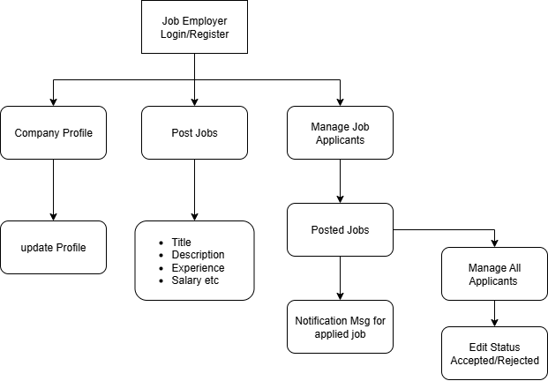

4**. Technology Stack**

* Frontend
  + HTML
  + CSS3
  + Bootstrap
  + jQuery
  + JavaScript
* Back-end
  + Predefined login credentials will be stored as JavaScript objects/arrays, while all user information and job post details will be kept in local storage.